Individual Testing

1. Assignment & Accountability
Contributor / Member ID | [samir Samir Eid]
Type of vulnerable | [SSRF]
Week / reporting period | [Week 1/ (23/10)]
Target / environment | Juice shop

2. Objective, Scope & Preconditions
[Objective: To assess whether the Profile Image URL feature in OWASP Juice Shop can be abused to trigger server-side requests (SSRF).
Scope: Authorized local OWASP Juice Shop instance running in Docker at http://localhost:3000.
Account/Role: Authenticated customer account.
Preconditions: User logged in, Profile page accessible, Burp Suite configured.
Exclusions: No production systems or unauthorized external services were tested.3]

3. Test Log
Date | Asset / Endpoint | Test case | Outcome | Evidence ID
23 Oct 2026 | http://localhost:  3000 prfile page | Accssed the profil  imageUrl feature | FeatureAccessible  While authenticated | E-01
23 Oct 2026 | Post/profile/image/url | Submitted the image URL | HTTP 302 Redirect | E-02
23 Oct 2026 | Score Board | Verified SSRF callenge | Completed | E-03

4. Finding Record (duplicate this section for each suspected/confirmed finding)
Finding ID / Title | F-01 – Potential Server-Side Request Forgery (SSRF)
Affected asset | OWASP Juice Shop – Profile Image URL Feature
Method / account role | Manual testing using Burp Suite with an authenticated customer account.
Severity / CVSS | Informational (Training Environment)

4.1 Summary
[The Profile Image URL functionality was tested for possible SSRF behavior. An image URL was submitted through the application, Burp Suite captured the request to /profile/image/url, and the application completed the training challenge.]

4.2 Preconditions
-OWASP Juice Shop running locally.
-Docker container active.
-User logged in.
-Burp Suite intercepting traffic.
-Profile page available.
]

4.3 Reproduction Steps
1. Start OWASP Juice Shop in Docker.
2.Open http://localhost:3000.
3.Log in with a customer account.
4.Open the Profile page.
5.Configure Burp Suite.
6.Enter an image URL in the Image URL field.
7.Click Link Image.
8.Capture the POST /profile/image/url request.
9.Verify the SSRF challenge was marked as completed.

4.4 Expected vs. Actual Result
Expected: [The application should validate image URLs and prevent unauthorized server-side requests.
Actual: [
The application accepted the submitted image URL, generated a POST /profile/image/url request, returned HTTP 302, and the SSRF training challenge became completed.]

4.5 Impact & Limitations
[IF SSRF exists in a real application, attackers may force the server to send requests to unintended destinations. In this training environment, only the challenge completion and captured requests were demonstrated..]

4.6 Remediation Recommendation
[-Validate image URLs.
-Use an allowlist for trusted domains.
-Block localhost and private IP ranges.
-Revalidate after redirects.
-Restrict outbound network access.
-Log rejected requests.
]

5. Evidence Register
Filename / location | Related finding | Sensitive data redacted?
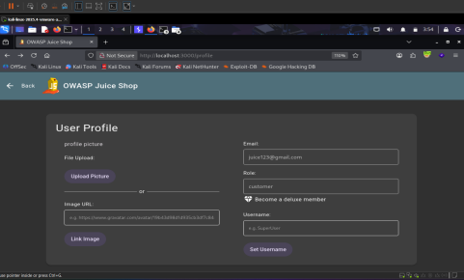 | [F-01] | [yes]
[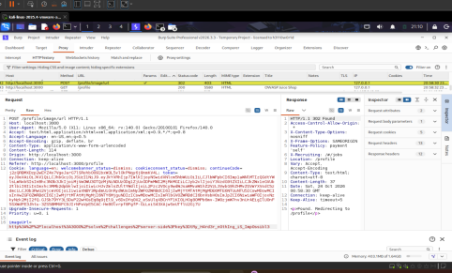 | [F-01] | [yes]
Filename / location | Related finding | Sensitive data redacted?
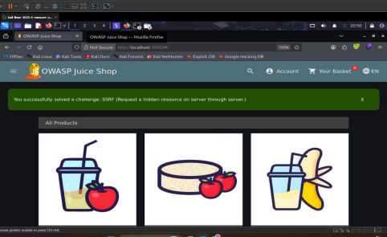 | [F-01] | [yes]

